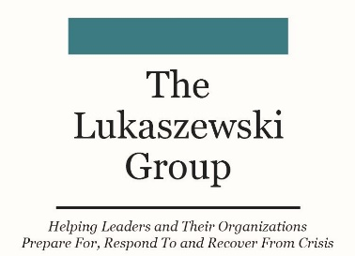
..LUKASZEWSKI’S
LEXICON OF CIVILITY, DECENCY,
AND TRUST

Pathways to Civility, Decency, and Integrity
By James E. Lukaszewski,
ABC, Fellow IABC, APR, Fellow PRSA, BEPS Emeritus,Ttrust Across America Lifetime Achievement

The true test of civility is a commitment to verbal, written communication, deeds and actions that benefit a recipient far more positively than the sender, including:

- Accountability
- Apology
- Candor
- Character
- Charitability
- Chivalry
- Civility
- Compassion
- Constructiveness
- Courtesy
- Decency
- Dignity
- Empathy: positive deeds that always speak louder than words.
- Engagement
- Forgiveness
- Helpfulness
- Honesty
- Honor
- Humility
- Integrity
- Openness
- Peacefulness
- Pleasantness
- Politeness
- Positivity
- Principle
- Respect
- Responsiveness
- Sensibility
- Sensitivity
- Simplicity
- Softness
- Tact
- Thoughtfulness
- Transparency
- Truthfulness

Each of these words is a pathway to civility, decency, integrity, and trust; pick as many as you can.
The reverse of any of these words only leads to more trouble, prolonged problems, delayed mitigation and resolution; revictimizing those who have been injured.

